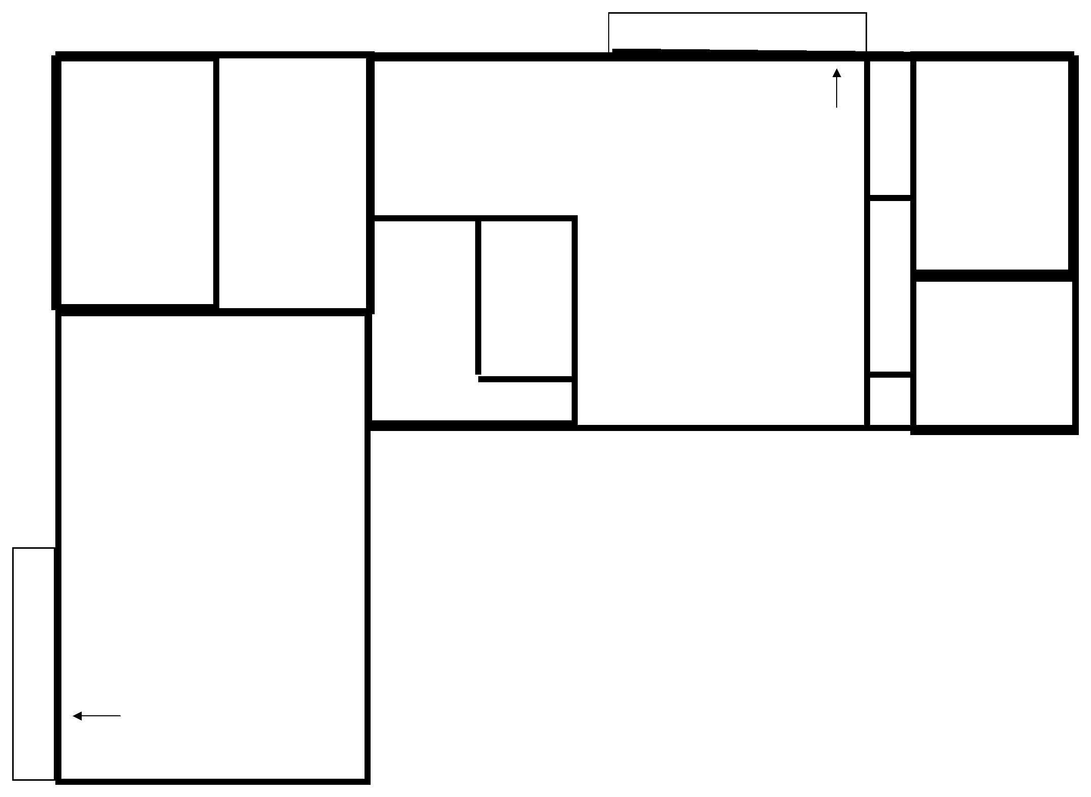

**W.C.**

**S h owe r**

**1.**

**2.**

**1.**

**2.**

**Fire Exit**

**DORMITORY Inc. 4 bunk beds**

**4.**

**5.**

**6.**

**7.**

**8.**

**9.**

**10.**

**11.**

**12.**

**13.**

**14.**

**15.**

**16.**

**17.**

**18.**

**19.**



**2.**

**DORMITORY**



**(bunk beds x 2)**

**SAVIO HOUSE ACCOMMODATION PLAN**

**THE BARN (UPPER FLOOR)**

**MAXIMUM CAPACITY = 41**

PLEASE COMPLETE USING FULL NAMES FOR EVERYONE ATTENDING AND THE FOLLOWING LETTERS TO ASSIST THE FIRE BRIGADE: B (for breathing) M (for mobility) S (for sensory)

**Fire Exit**

**DORMITORY Inc. 3 x bunk beds)**



**Toilets and showers**

**Toilets and showers**

**Group Name______________________________________________________ No. of persons___________**